600091_A25_T12: Honours Stage Project
Interim Report
Date Due: 13/01/2025
Word Count: 1874

Table of Contents
Table of Contents 2
Table of Figures 2
1. Project Overview 4
1.1 Introduction 4
1.2 Project Aims & Objectives 4
2. Project Technical Progress 5
2.1 Requirements Capture and Analysis 5
2.2 Design 5
2.3 Remaining Implementation 5
3. Project Management 6
3.1 Personas and User Stories 6
3.2 Modified Project Plan 6
3.3 Updated Gantt Chart 7
3.3.1 Original Gantt Chart 7
3.3.2 Modified Gantt Chart 8
3.4 Management Reflection 8
4. Appendix 9
Appendix A 9
Appendix B 10
Appendix C 12
Appendix D 15
5. References 16

Table of Figures
Figure 3.1 – Original Gantt Chart from PDD 7
Figure 3.2 - Modified Gantt Chart 8
Figure 4.1 - Figma Prototype: Menu Page 10
Figure 4.2 - Figma Prototype: Timers Page 10
Figure 4.3 - Figma Prototype: Timers Sub Menu 11
Figure 4.4 - Figma Prototype: Calendar Page 11
Figure 4.5 - Persona: ' Harriet Emmerson' 12
Figure 4.6 - Persona: 'Ethan Hooton' 13
Figure 4.7 - Persona: 'Noelle Holiday' 14
Figure 4.8 - Screenshot from 'Gamification Strategy to Support Self-Directed Learning in an Online Learning Environment' 15

Project Overview

1.1 Introduction
Since the Covid-19 pandemic in 2020, the move towards online learning and self-driven work has increased (Lemay et al., 2021). As such, students are encouraged more than ever to self-motivate for their studies, of which some of whom will find difficult (Grøtan et al., 2019). Mobile applications have been shown to improve user’s time management and resource management (Baars et al., 2022), and as the majority of people own some form of smartphone, it seems the natural place to implement a motivation-based application. Gamification (Deterding et al., 2011) is the process of using common game features such as earning currency, competing for awards, and earning experience (XP), to incentivise users with rewards to complete tasks. Using gamification to motivate users has been shown to greatly improve their academic performance as shown in Appendix D (Palaniappan & Md Noor, 2022).

1.2 Project Aims & Objectives
- Provide resources for users to use to track progress within the app
- Implement a method of saving recorded times into a calendar
- Include features to incentivise users through gamification
- Create a hosted application which stores and displays these features

Project Technical Progress

2.1 Requirements Capture and Analysis
To correctly identify the scope and ensure consistent and specific project objectives, project requirements must be gathered and refined to create a clear pathway for the project and it’s aims. Appendix A contains an example of one requirement used in this project, which includes a priority rating (1 – Highest priority, 5 – Lowest priority), description of the requirement, user inputs, feature or application outputs, any persistent changes made, and any related requirements or use cases to track which user stories are being fulfilled.

2.2 Design
It was important to design the application according to existing project heuristics (Gonzalez-Holland et al., 2017) to improve the user experience and keep the application both easy to use and simple to understand. High fidelity prototypes can simulate some functionality and show user flows and are relatively quick to create rather than a full in-framework mock-up. Figma (Figma: The Collaborative Interface Design Tool, n.d.) is a design tool which can be used to create high-fidelity prototypes. Appendix B contains the high-fidelity prototype of the application design.
Two University-provided Virtual Machine (VM) will be used to host the application through API calls to the database. One VM (STU-706631-VM2.net.dcs.hull.ac.uk) is a development environment to facilitate testing and debugging, the other VM (STU-706631-VM3.net.dcs.hull.ac.uk) will be used to host the final project. Both VMs run on Windows Server 2025 (Windows Server 2025 | Microsoft Evaluation Center, n.d.) which is optimised for quick database access. The proposed database platform Firebase (Firebase | Google’s Mobile and Web App Development Platform, n.d.) contains many resources for both developing and publishing applications such as user authentication and app hosting.

2.3 Remaining Implementation
There are many remaining areas which need executing. As Alpha phase has been delayed due to poor planning, much of the initial design and implementation is yet to be completed. Development will start with a NoSQL database and backend design created with Firebase, which will inform how the frontend stores and interacts with the application. By using a Docker container (Docker: Accelerated Container Application Development, n.d.), the application will be isolated from the host machine, securing it against malware and intrusion. The frontend application will be written in React Native (React Native · Learn once, write anywhere, n.d.), due to its widespread industry adoption.

Project Management

3.1 Personas and User Stories
Personas are commonly used to guide feature goals and consider additional characteristics not defined in the requirements. By creating rounded personalities and attributing them to use cases, each requirement can be better conceptualised by the developer. The three main personas created for this project are cited in Appendix C. Two of the personas are students as the app is primarily aimed at those in full-time education.
Formal requirements can be reworked into user stories which promotes a user-focused outlook. User stories follow a set format that takes the user/actor into consideration as well as dissecting why each requirement is necessary. For example, “As a small business owner, I want to track my working hours so that I can calculate my labour costs.” Is a user story which uses the ‘Noelle’ persona, an online retailer, to justify saving the recorded time spent working into the calendar feature. Restructuring requirements this way demonstrates a broader application of each feature within the confines of the project.

3.2 Modified Project Plan
The Gantt chart below has been modified to show the gap in work done between the Discovery Phase and the beginning of Alpha Phase. The progress bar has also been updated to show how much work was completed within the Discovery Phase. The sprints have been moved 2 weeks forward to make up the time loss. As this was an expected risk, substantial buffer time was worked into the original Gantt chart between the end of development and the final report submission which can now be used to make up the lost time.

3.3 Updated Gantt Chart

3.3.1 Original Gantt Chart
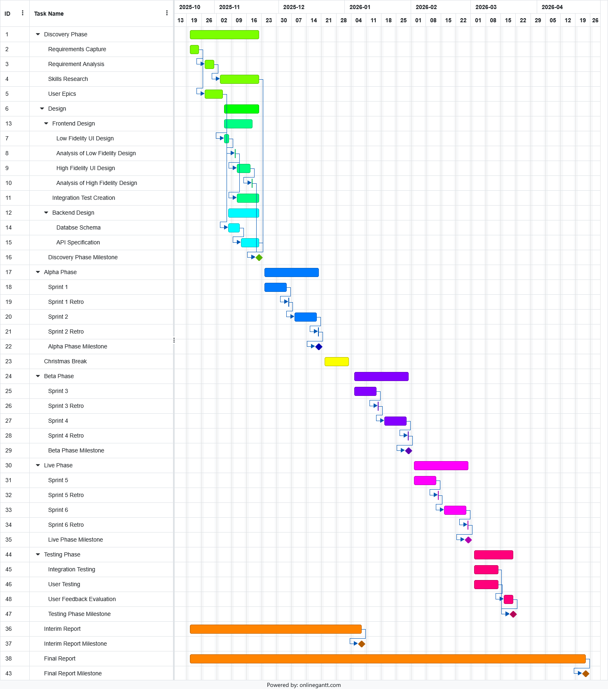
Figure 3.1 – Original Gantt Chart from PDD

3.3.2 Modified Gantt Chart
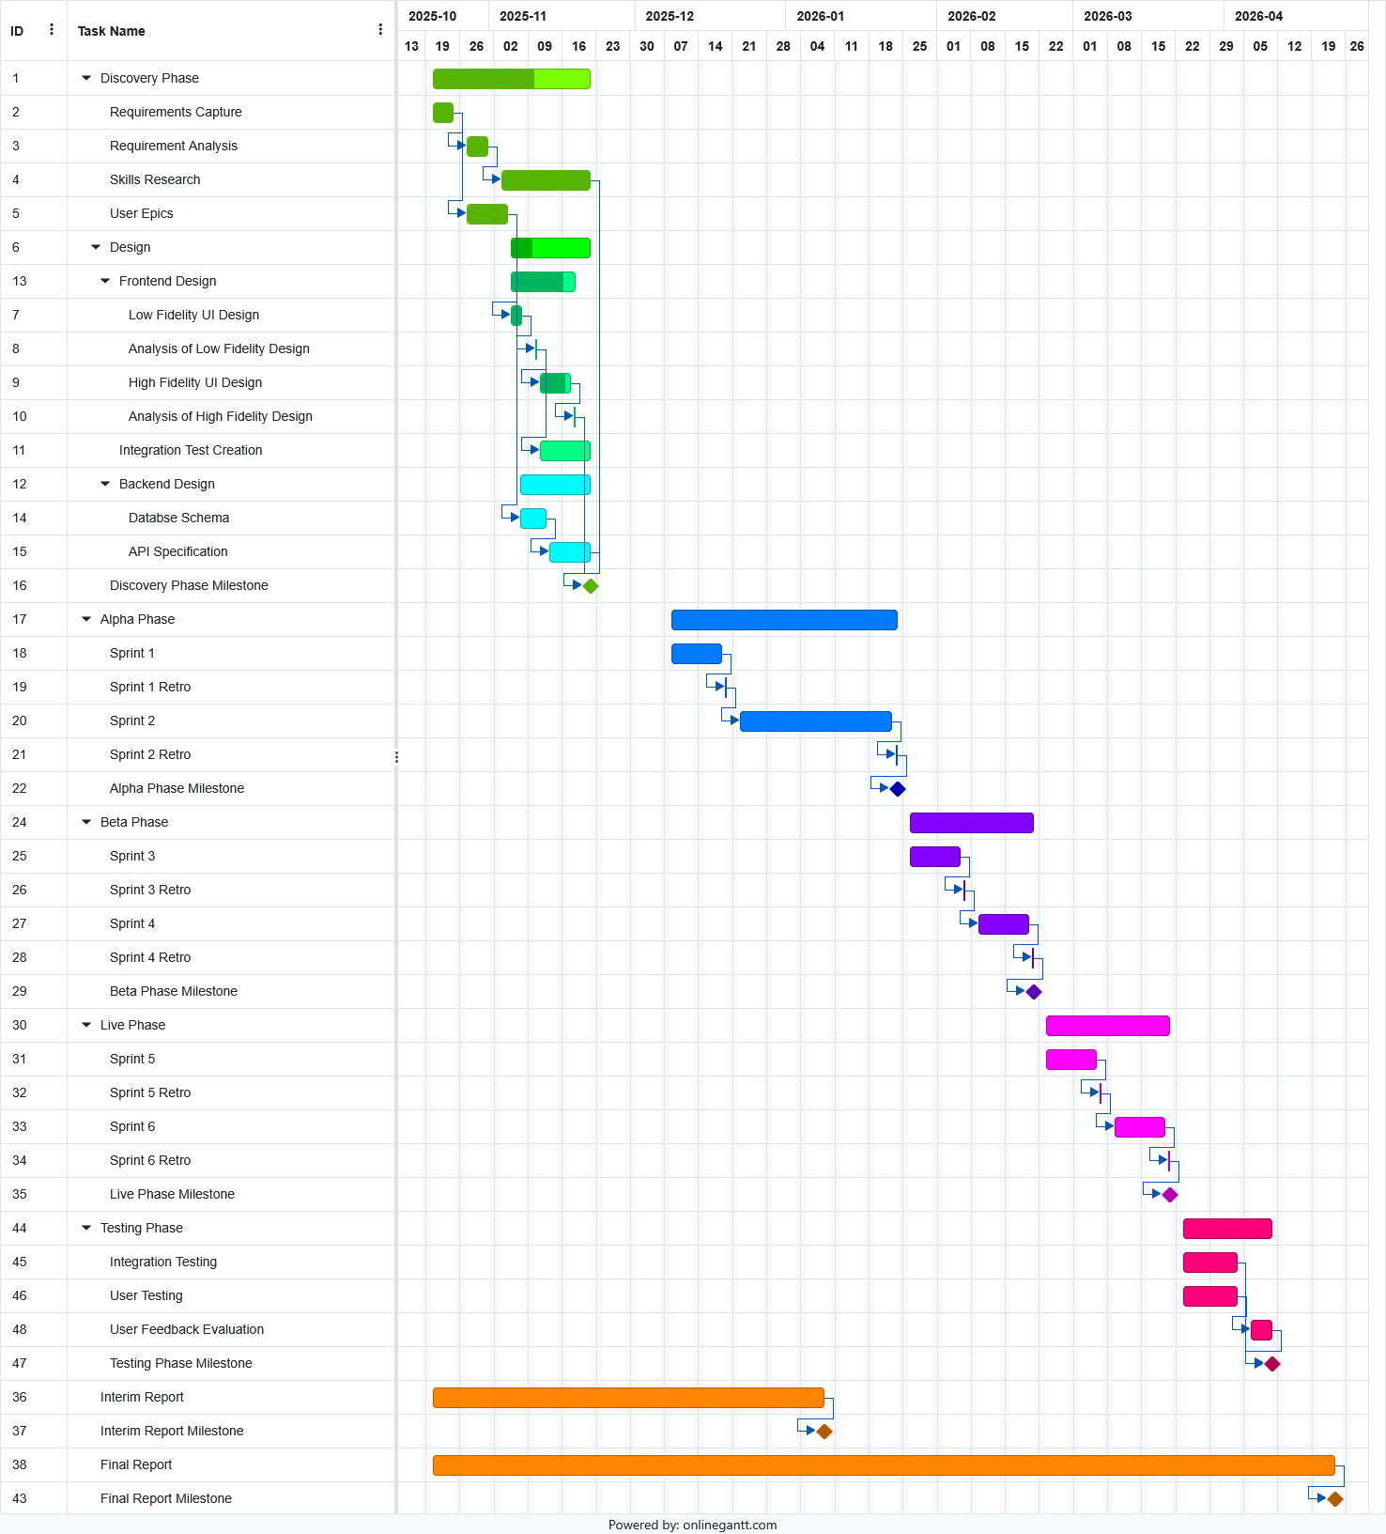
Figure 3.2 - Modified Gantt Chart

3.4 Management Reflection
This project has suffered significantly from a lack of consistent work. Most of the work shown was completed in small inconsistent bursts, which resulted in scattershot progress on often inconsequential areas. Going forward there must be a substantial change in production and how the project is run.

Appendix

Appendix A
Requirement ID: R1.4
Requirement priority: 1
Requirement Description: The user must be able to delete their account
Inputs: user email, user password
Outputs: error message, confirmation message, confirmation email
Persistent Changes: user account is deleted from the database as well as all information connected to account
Related Requirements and Use Cases: R1.1, R1.2

Appendix B
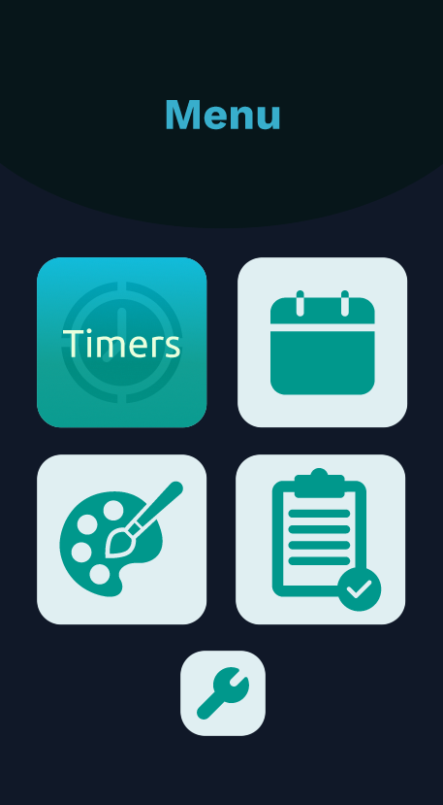
Figure 4.1 - Figma Prototype: Menu Page
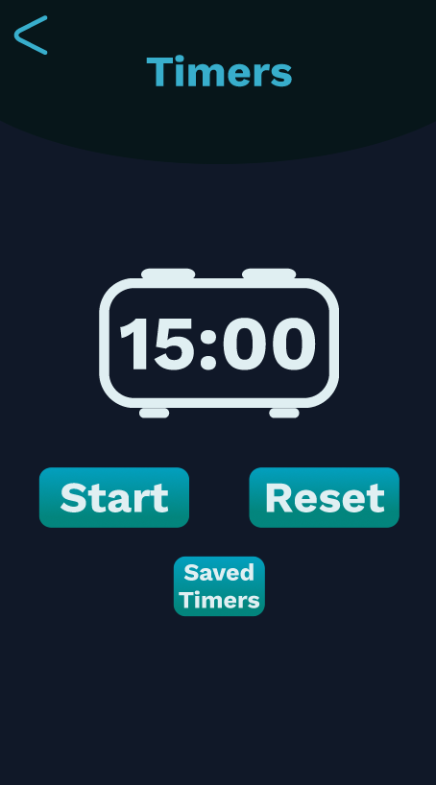
Figure 4.2 - Figma Prototype: Timers Page
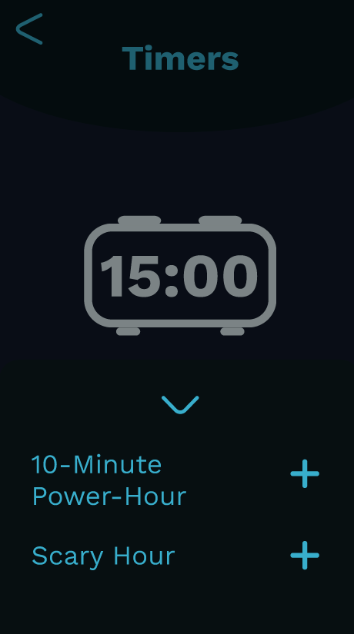
Figure 4.3 - Figma Prototype: Timers Sub Menu
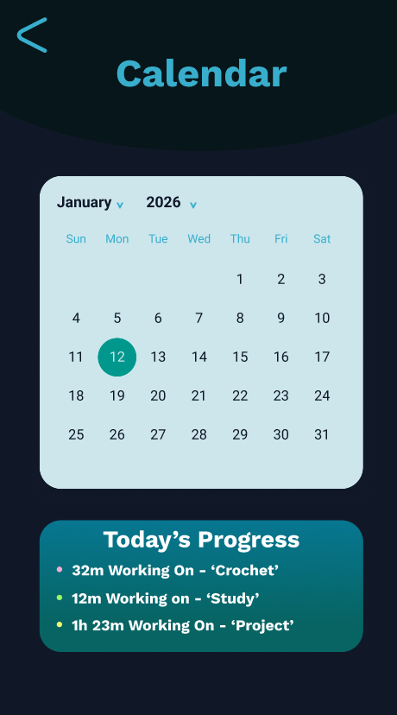
Figure 4.4 - Figma Prototype: Calendar Page

Appendix C
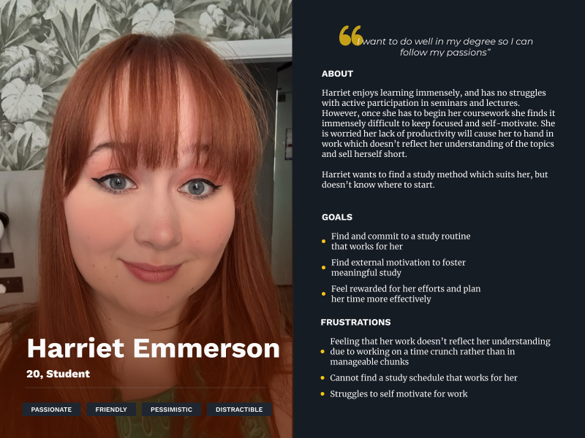
Figure 4.5 - Persona: ' Harriet Emmerson'
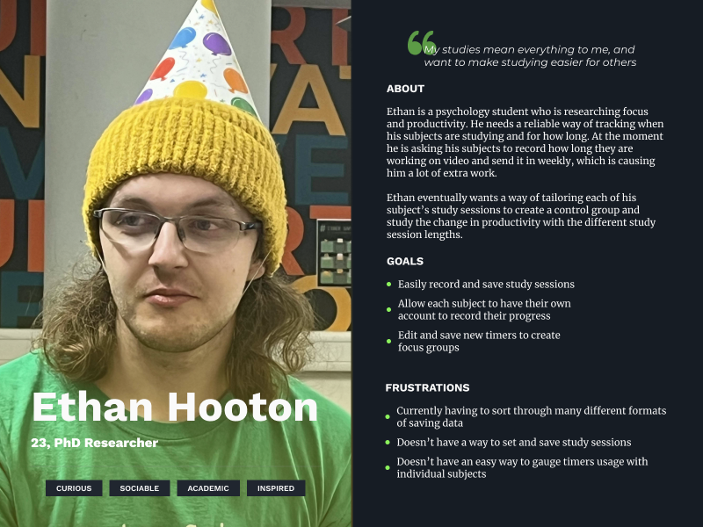
Figure 4.6 - Persona: 'Ethan Hooton'
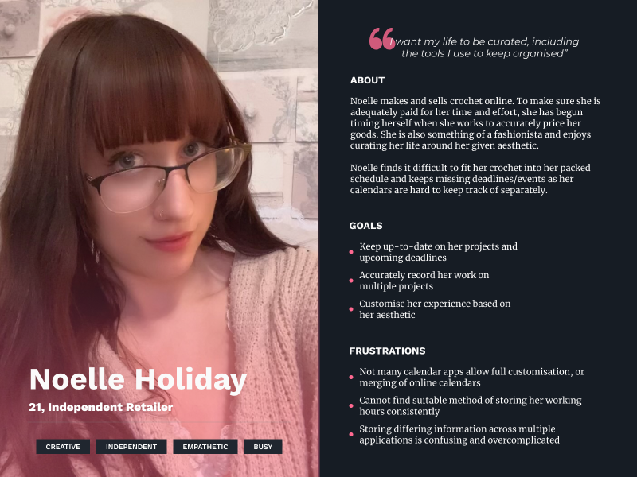
Figure 4.7 - Persona: 'Noelle Holiday'
All photographs used were done so with the consent of those photographed.

Appendix D
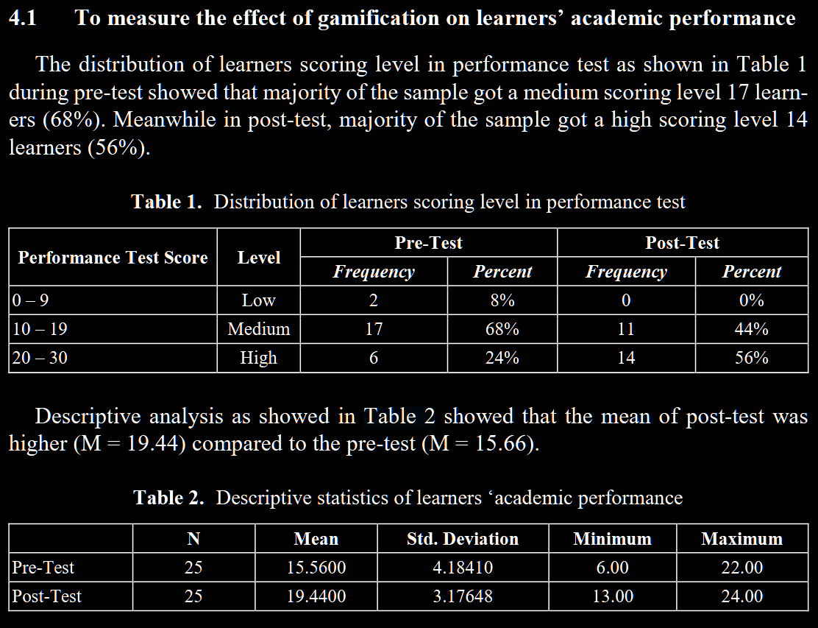
Figure 4.8 - Screenshot from 'Gamification Strategy to Support Self-Directed Learning in an Online Learning Environment'

References
Gonzalez-Holland, E., Whitmer, D., Moralez, L. & Mouloua, M. (2017) Examination of the Use of Nielsen’s 10 Usability Heuristics & Outlooks for the Future. Proceedings of the Human Factors and Ergonomics Society Annual Meeting, 61(1), p. 1472–1475. Available online: https://doi.org/10.1177/1541931213601853.
Ace your Self-Study app | Educational Innovation | Erasmus University Rotterdam (n.d.). https://www.eur.nl/en/educational-innovation/news/ace-your-self-study-app [Accessed 12 Jan 2026].
Baars, M., Khare, S. & Ridderstap, L. (2022) Exploring Students’ Use of a Mobile Application to Support Their Self-Regulated Learning Processes. Frontiers in Psychology, 13, p. 793002. Available online: https://doi.org/10.3389/fpsyg.2022.793002.
Forest - Stay focused, be present (n.d.). https://www.forestapp.cc/ [Accessed 12 Jan 2026].
Grøtan, K., Sund, E.R. & Bjerkeset, O. (2019) Mental Health, Academic Self-Efficacy and Study Progress Among College Students – The SHoT Study, Norway. Frontiers in Psychology, 10, p. 45. Available online: https://doi.org/10.3389/fpsyg.2019.00045.
Munson, S. & Consolvo, S. (2012) Exploring Goal-setting, Rewards, Self-monitoring, and Sharing to Motivate Physical Activity. In Proceedings of the 6th International Conference on Pervasive Computing Technologies for Healthcare. 6th International Conference on Pervasive Computing Technologies for Healthcare, IEEE. Available online: https://doi.org/10.4108/icst.pervasivehealth.2012.248691.
Palaniappan, K. & Md Noor, N. (2022) Gamification Strategy to Support Self-Directed Learning in an Online Learning Environment. International Journal of Emerging Technologies in Learning (iJET), 17(03), p. 104–116. Available online: https://doi.org/10.3991/ijet.v17i03.27489.
Sierra Nevada College. Department of Humanities, Psychology Program., Ruuymaekers, A. & Frederick, C. (2018) Ascending versus Descending Timers: Stress and Motivation. Nevada State Undergraduate Research Journal, 4(1), p. 25–30. Available online: https://doi.org/10.15629/6.7.8.7.5_4-1_S-2018_3.
Why Use Personas in Agile Development? (n.d.). https://userpersona.dev/blog/why-use-personas-in-agile-development [Accessed 12 Jan 2026].
Windows Server 2025 | Microsoft Evaluation Center (n.d.). https://www.microsoft.com/en-us/evalcenter/evaluate-windows-server-2025 [Accessed 13 Jan 2026].
Firebase | Google’s Mobile and Web App Development Platform (n.d.). https://firebase.google.com/ [Accessed 13 Jan 2026].
Deterding, S., Dixon, D., Khaled, R. & Nacke, L. (2011) From game design elements to gamefulness: defining ‘gamification’. In Proceedings of the 15th International Academic MindTrek Conference: Envisioning Future Media Environments. MindTrek ’11: Academic MindTrek 2011, ACM, p. 9–15. Available online: https://doi.org/10.1145/2181037.2181040.
Docker: Accelerated Container Application Development (n.d.). https://www.docker.com/ [Accessed 13 Jan 2026].
React Native · Learn once, write anywhere (n.d.). https://reactnative.dev/ [Accessed 13 Jan 2026].

